

UNIVERSITY OF PETROLEUM & ENERGY STUDIES
Dehradun

CONTINOUS INTEGRATION
AND
CONTINOUS DELIVERY

Experiment

Name: Madhav Bhatia
Course: B. TECH CSE DevOps (2018-22)
Roll no.: R171218061
Sapid: 500068227

Experiment-1
Installation of Jenkins

Step-1: Go to the link for downloading the Jenkins .war file.
https://www.jenkins.io/download/
We require .war for this experiment.

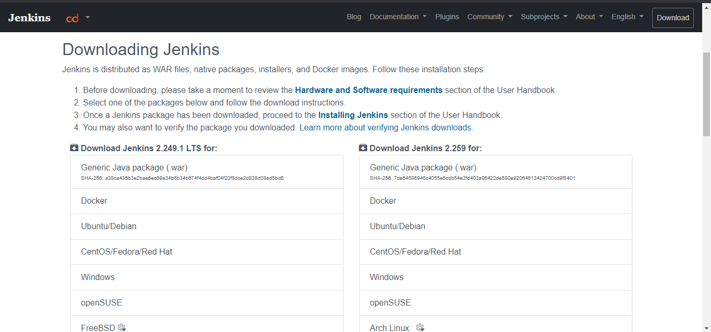

Step-2: After downloading the file transfer that file to a specify folder and name the folder Jenkins. After completing this process open command line for the specific folder.
To start run the Jenkins use “java -jar Jenkins.war”

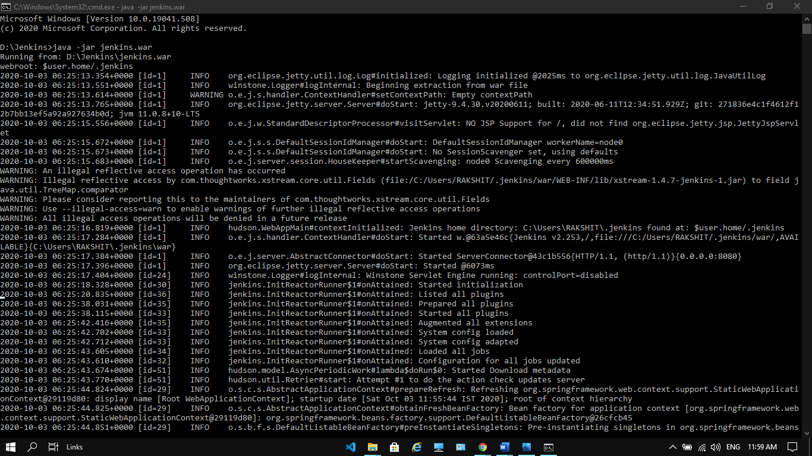

Step-3: Go to Browser. Type “localhost:8080” and press enter.
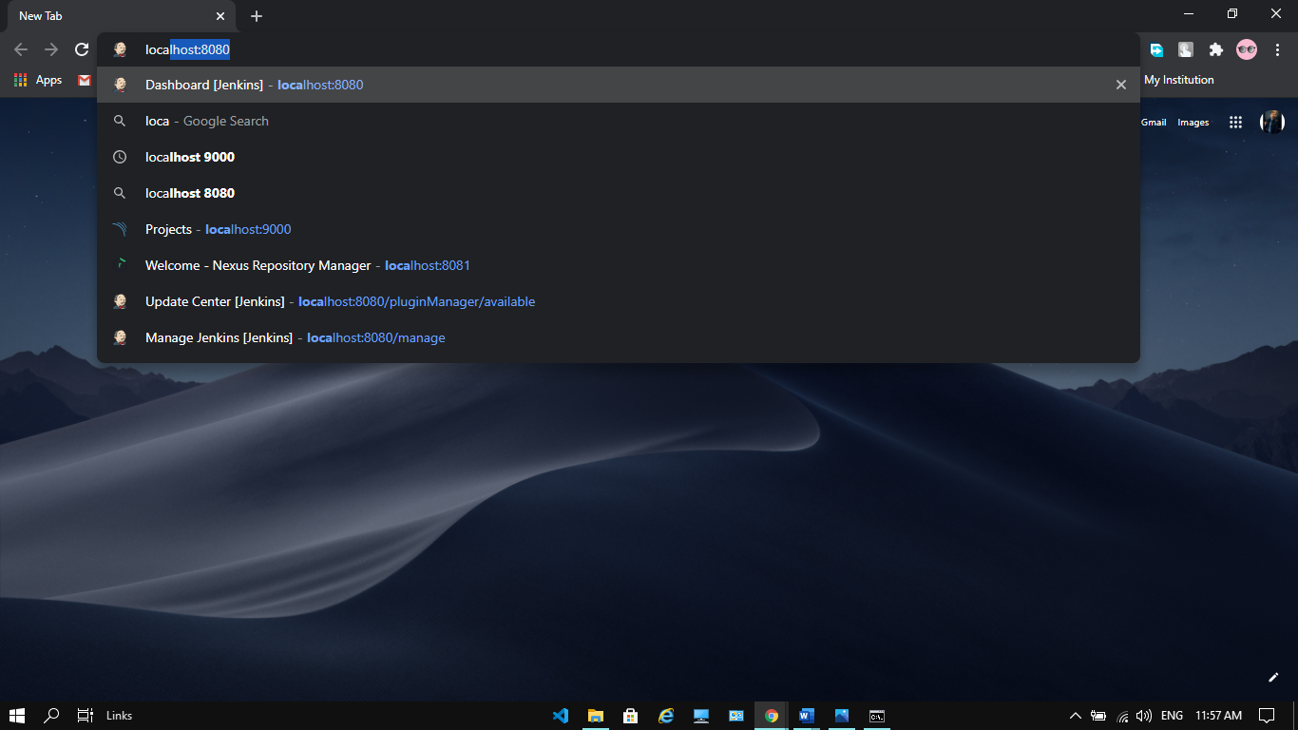

Step-4: This Window will appear.

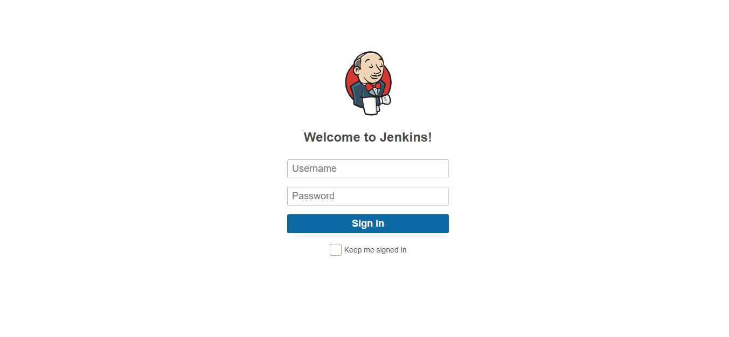
Step-5: Enter the username and password, at the time of first login the username and password would be admin. After signup enter all the details as required and you can further change username and password.
Step-6: Your welcome window will appear with your username.

